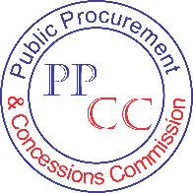

Public Procurement and Concessions Commission
Executive Mansion Grounds, Capitol Hill, Monrovia, Liberia

CIPS Levels 2 &3 Training Report

Held At

Bella Casa Hotel In Sinkor

Date: June 19-23 & 26-30, 2017

Funded by: United Nations Development Program

Contents

Overview 3
Opening remarks 3
Proceedings of Facilitation 4
Challenges 4
Risks------------------------------------------------------------------------------------------------------- 4
Lessons Learned----------------------------------------------------------------------------------------- -4
Recommendations 5
Pactorial 6
Annex 1: Attendance 7

Overview

The procurement professionalization effort was launched in 2015 by the Public Procurement and Concessions Commission (PPCC) in partnership with United Nations Development Program(UNDP), to address the huge capacity deficit in the field of procurement and qualify Liberia’s public sector procurement staffs for certificate awards in purchasing and supply from the UK based Chartered Institute of Purchasing and Supply (CIPS). This effort commenced with the conduct of the maiden session of CIPS level 2 introductory certificate training in Liberia that witnessed the participation of nearly 90 public sector staffs involved with public procurement at various ministries and agencies of government. The results from these initial interventions opened new opportunities for the conduct of advance professional certificate courses in Purchasing and Supply. Consequently, the first two sessions of CIPS level 3 were held in February and March, 2017 but could not accommodate all of the participants from the previously held CIPS Level 2 introductory course. To address this situation, another round of CIPS level 3 training sessions was held at Bella Casa Hotel, from June 19-23, 2017. This session had a record attendance of 31 procurement practitioners. The Commission also conducted an additional session of CIPS level 2 as part of efforts to address the capacity deficit and professionalize public procurement. A total of 42 participants drawn mainly from the Intensive Procurement Training Program(IPTP), received the training held from June 26-30, 2017.

Remarks:
MFDP
The Ministry of Finance and Development Planning (MFDP) was represented by Mr. Sidikie Quisia, Director of Regional and Sectorial Planning. Mr. Quisia said the Ministry will continue to work with the PPCC to build capacity of procurement staff involved with public procurement. Director Quisia said MFDP will remain engaged with UNDP to ensure achievement of procurement professionalization efforts launched by PPCC in 2015.
UNDP
UNDP Country Director, Pa Lamin Beyei, underscored the need for a professional public procurement system that is built on integrity and accountability. He said corruption in public procurement undermines development and deprives growth. Mr. Beyei called for concerted efforts in fighting corruption. He warned that unless the fight against corruption is taken very seriously, the development drive of Liberia will be compromised. The UNDP boss lauded PPCC for the innovation and the leadership role played in the development of procurement capacity of public sector procurement staff. He pledged his institution’s continued support towards the capacity building initiatives of PPCC.
PPCC
The Chief Executive Officer of PPCC, Mr. James Dorbor Jallah, recounted UNDP support to the PPCC in its drive to professionalize public procurement in Liberia. He accentuated that such support has immensely contributed to the capacity building efforts launched by PPCC to ensure effectiveness and efficiency in public procurement.
3
Mr. Jallah said the Commission will continue to work with procuring entities to develop and strengthen capacity of procurement staff within the employ of government. He challenged the participants to take advantage of the training opportunity to enhance their knowledge in public procurement.
Proceedings of Facilitation

Presentations
The training was facilitated by Mr. Poul Muller, from the Procurement Support Office (PSO) of United Nations Development Program(UNDP) in Copenhagen, Denmark. Mr. Muller covered the entire Level 2 &3 Course modules which included classroom exercises, group works, as well as assignments. Both courses seek to develop and strengthen the capacity of public service staff involved with procurement with a view to cost effectively undertake procurement of goods, services and works in accordance with established financial rules and PPC Act. It provides practical advance knowledge to the specifics of the procurement process and covers key procurement issues such as strategy development, risk management, specification, supplier research, evaluation, contracts development, contract performance management, communications, negotiations, and professional development.

Challenges
The key challenge in this domain remains lack of stronger policies and legislations to protect procurement staff trained by PPCC from arbitrary removal. In several instances trained procurement staff have been removed and replaced with untrained ones. This action has hampered PPCC intentions to brew a well-functioning procurement system in Liberia. Another challenge is the absence of a professional body to regulate the conduct of procurement practitioners. Procurement personnel who commit ethical breaches are usually allowed to go with impunity. They move to similar jobs in public service unchecked. Unless this is changed, the public procurement system remains the biggest challenge in the fight against corruption in Liberia.
Risks
The risk factor is that those trained under this program could seek employment opportunities elsewhere if they find themselves underutilized and underpaid.
Lessons Learned
The training marks the beginning of efforts to institute a well-functioning procurement system in Liberia. The tutor of the course demonstrated understanding and competence in delivering the materials. Participants are now armed with the necessary procurement knowledge and a required skill-set to undertake procurement in a more effective and efficient manner.

4
Recommendations
The beneficiaries expressed enthusiasm for the opportunity accorded them through the collaborative initiative of PPCC and UNDP to qualify them for the UK based Chartered Institute of Purchasing and Supply(CIPS) certificate awards in purchasing and supply. They advanced the following issues as those that should be considered by PPCC in its endeavor to professionalize public procurement:
- PPCC should remain engaged with UNDP and other partners to ensure a complete professionalization of public procurement in Liberia via provision of professional training opportunity in public procurement.
- That trained procurement practitioners are protected from unlawful dismissal, and
- That training should have a longer duration so as to appropriately cover the prescribed course modules.

5
A Pictorial of CIPS Levels 2 & 3 Training Sessions Held at Bella Casa Hotel in Sinkor
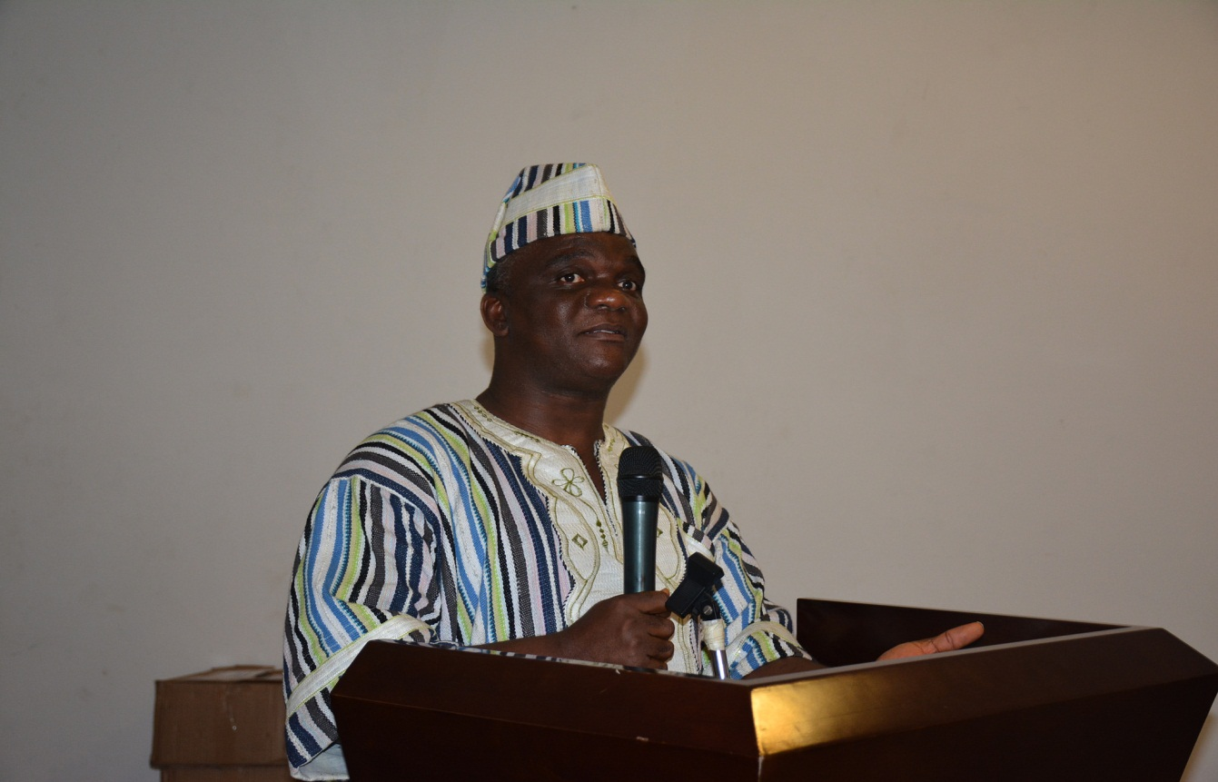
PPCC Chief Executive Officer, James Dorbor Jallah, delivers remarks at the start of the training session
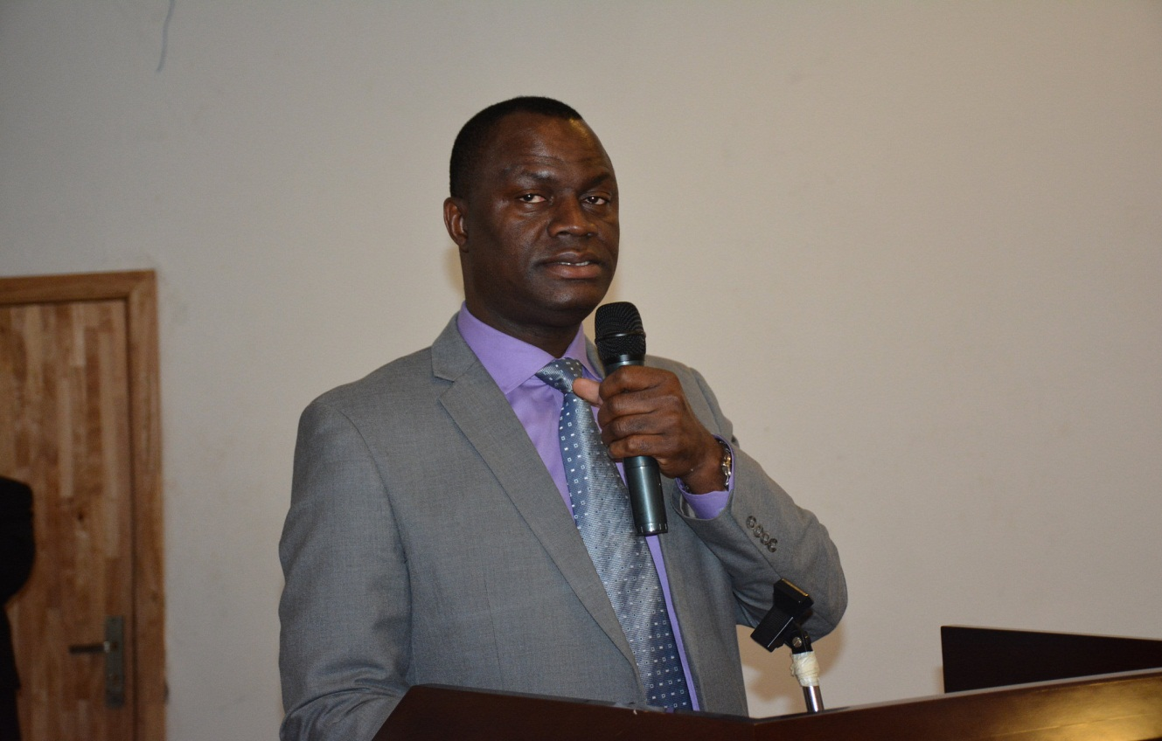
UNDP Country Director, Pa Lamin Beyei, speaks at the opening session of the training
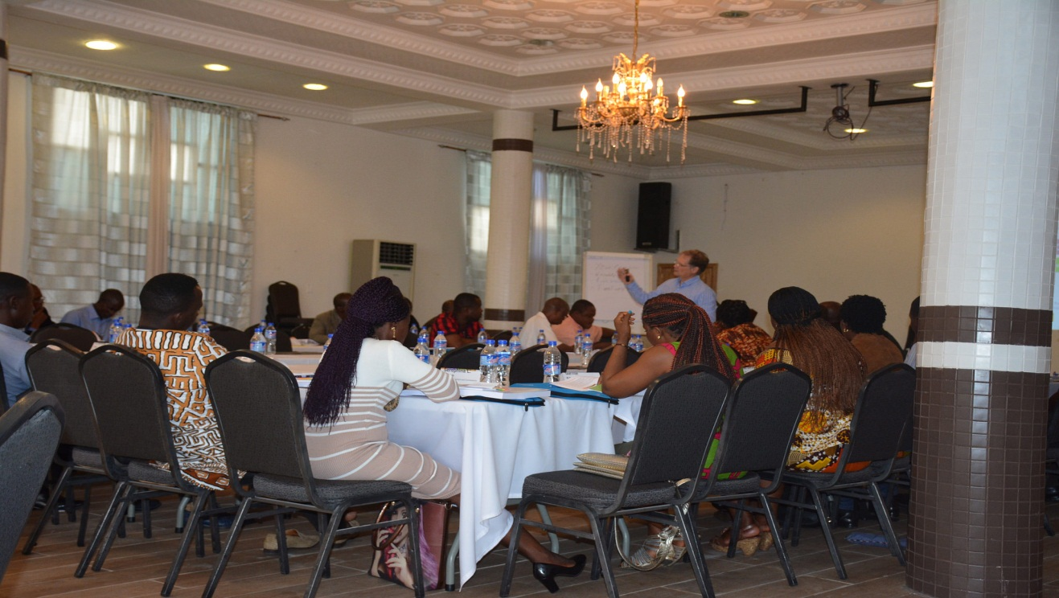
Participants listen attentively as the course tutor delivers lectures
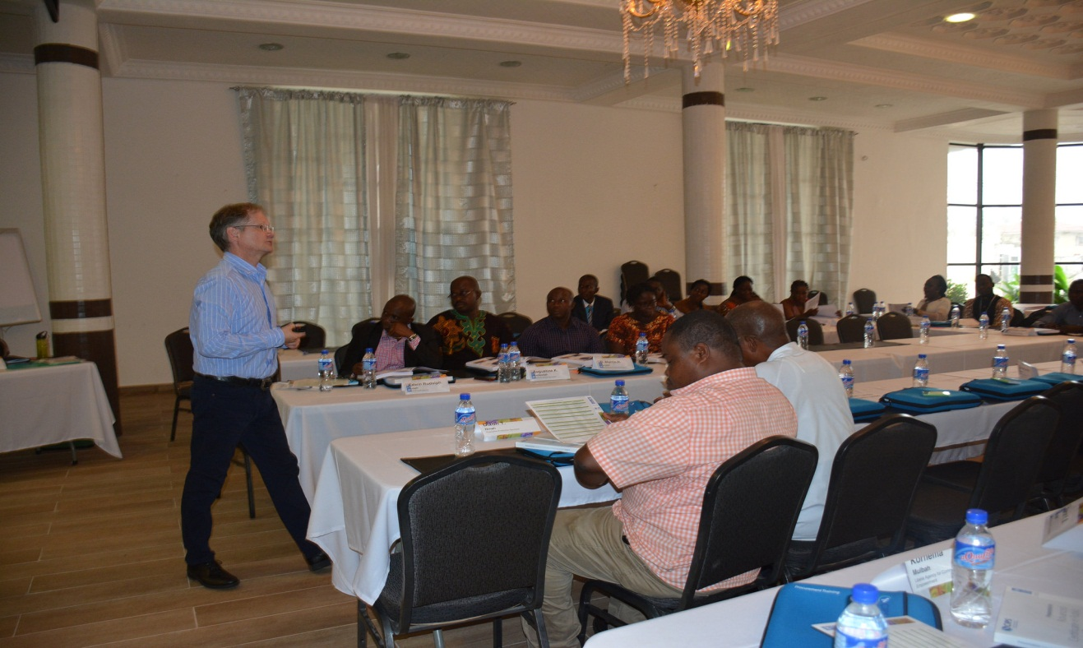
Course Tutor, Poul Muller delivers lectures as participants listen

